

Lasell University Athletics
Visitors Guide
Contacts
Administration
AVP – Jamie Marcoux – 617-243-2358
Morgan Choquet - Director of Athletic Communications – 401-309-7282
Chris Ikier – Director of Athletic Training - 617-243-2297

Athletic Training
Welcome:
The Lasell University Sports Medicine staff welcomes you to our campus! The following information will assist your teams in preparation for their upcoming visit.

Coverage:
A Certified Athletic Trainer will be available and covering all home contests. The respective athletic training room will be open 120min prior to the start of each contest and will close shortly after the conclusion of the contest. We ask that you notify our staff, in advance, if the team is traveling without a certified athletic trainer. Please inform our staff of any needs that the team may have prior to and after the contest. There will be limited availability to modalities for pre-game treatment for the visiting team. Ice will be available after and during the game.

Supplies:
Please travel with a stocked med kit and cups or water bottles, availability to cups may be limited. The following will be placed on the visiting team bench for the team’s convenience.
• Ice
• Water

Facilities:
Contests held on Grellier Field will utilize the athletic training room in the basement of Forest Hall, down the hall from the locker rooms. Contests held on Taylor Field or in the Athletic Center will utilize the athletic training room in the Athletic Center, located on the ground floor.

Taylor Field
Men/Women’s Soccer & Softball
200 Woodland Ave, Auburndale, MA
Parking:
Team Buses should park in the Central Parking Lot (P4) after dropping teams off at the Athletic Center.

Spectators should park in Central Lot, P4 on Campus Map.

Locker Rooms:
The locker room and field access will be available 1.5 hr before game time.
NOTE: On days where we are hosting a doubleheader, teams must clear out locker rooms prior to their matchup so teams for the following contest can use the facilities.

Grellier Field
Field Hockey & Men/Women’s Lacrosse
33 Forest Ave, Auburndale, Mass.
Parking:
Team buses should park at 251 Woodland Road after dropping teams off at Grellier Field (Area will be marked Bus Parking and driver is to stay with the vehicle.) For buses to drop teams off at Grellier Field, take Forest Ave. and turn right into the Forest parking lot. After dropping off the team please exit out of the lot and turn right onto Studio Road and park at 251 Woodland Road.
Spectator’s can park in the Forest Lot, P8 on campus map.
NOTE: Parking is prohibited on Studio Road, Aspen Avenue, and Forest Avenue.

Locker Rooms:
The locker room and field access will be available 1.5 hr before game time.
NOTE: On days where we are hosting a doubleheader, teams must clear out locker rooms prior to their matchup so teams for the following contest can use the facilities.

Athletic Center
Men/Women’s Volleyball & Men/Women’s Basketball
200 Woodland Ave, Auburndale, MA
Parking:
Team Buses should park in the Central Parking Lot (P4) after dropping teams off at the Athletic Center.

Spectators should park in Central Lot, P4 on Campus Map.

Locker Rooms:
The locker room and field access will be available 1.5 hr before game time.
NOTE: On days where we are hosting a doubleheader, teams must clear out locker rooms prior to their matchup so teams for the following contest can use the facilities.

Stein Diamond
Baseball
415 South St., Waltham, MA
Parking:
Team Buses should drop team off by the field, and head down to the right to the Team Bus lot located behind the gymnasium.

Spectators should park in Central Lot, located directly to the right when entering the complex.

Locker Rooms:
There are NO locker rooms available onsite, there are public bathrooms onsite.

Campus Map

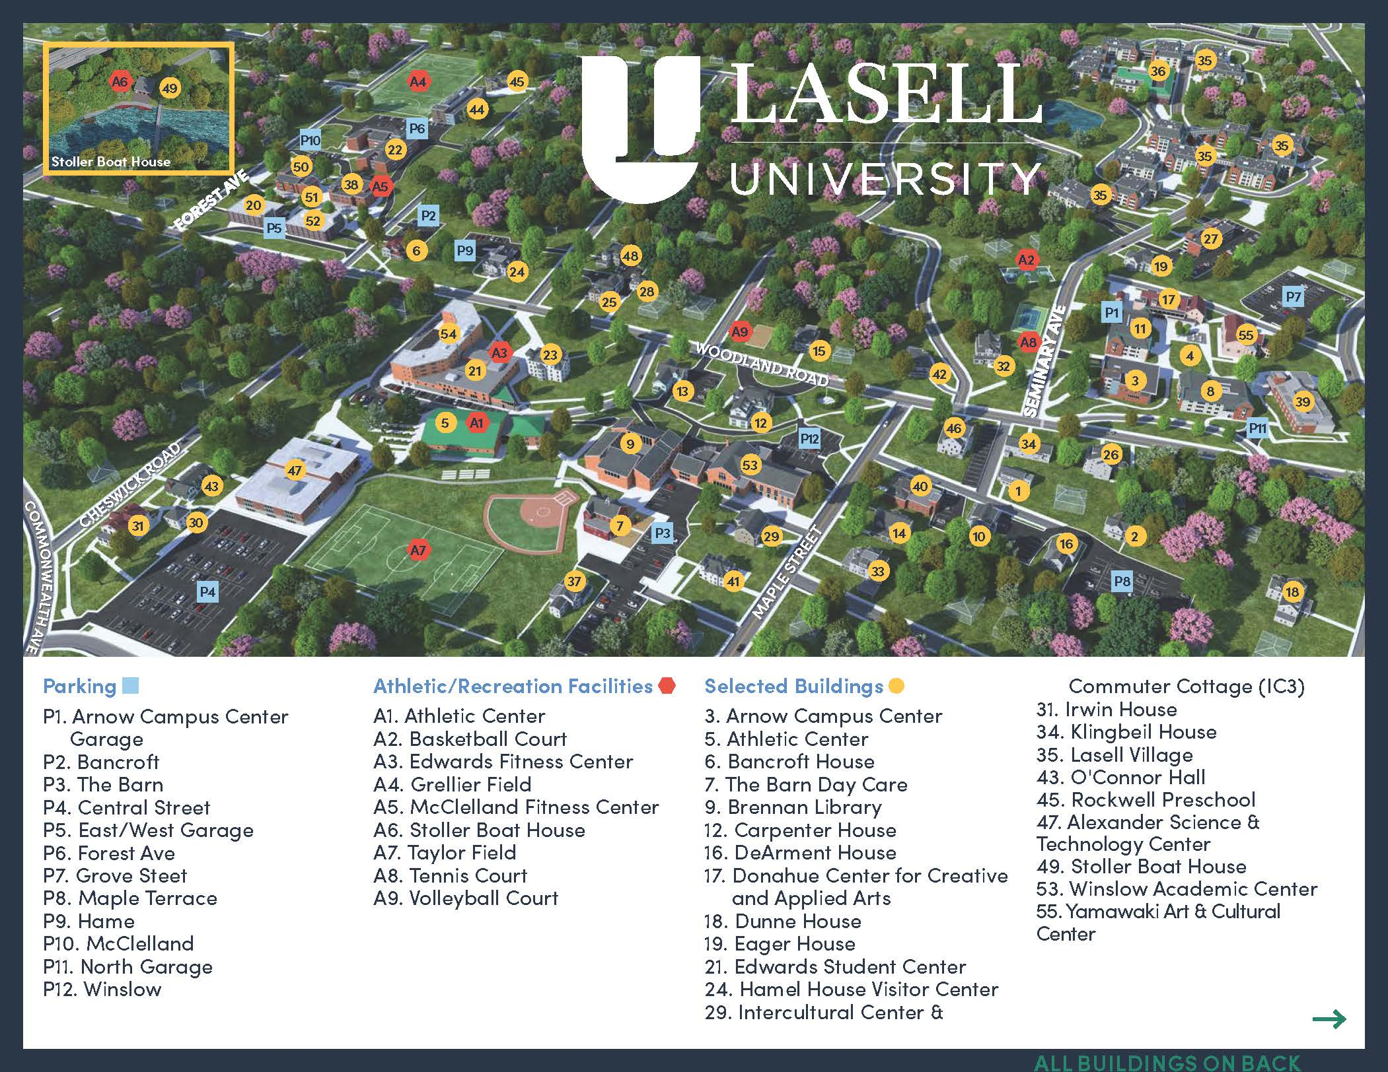

Local Dining
Toms Pizza – 423 Lexington St. Newton, MA 02466
617-969-4979

Comellas – 1302 Washington St. Newton, MA 02465
617-928-1001

Blue Ribbon BBQ – 1375 Washington St. Newton, MA
617-332-2583

Brueggers Bagels – 2050 Commonwealth Ave Auburndale, MA 02466
617-964-9508

